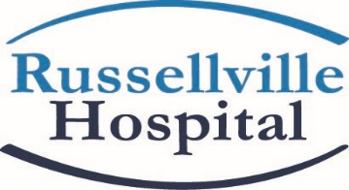
Updated Visitation Guidelines for Support Person/Caregiver
Effective May 18, 2020
Our first priority at Russellville Hospital is always the health and safety of our patients, your families and our staff. We understand that the current environment has created unexpected challenges for you and for us. Thank you for your patience and cooperation as we seek to deliver safe, quality care to you and your loved ones. In order to do so, there are guidelines for your support person/caregiver during this time of restricted visitation:
- All support persons/caregivers must be 16 years of age and older.
- All support persons/caregivers will be screened for fever/temperature.
- Anyone exhibiting symptoms of illness will not be allowed in our facility.
- All support persons/caregivers must wear a mask or appropriate face covering, must observe social distancing and must sanitize their hands frequently.
Supporting an adult patient
A point of contact (family member or caregiver age 16 and over) and a support plan are established upon admission. The point of contact will be communicated with, at a minimum of once daily, if desired.

For NON COVID-19 patients,
one (1) support person is allowed under the following circumstances:

Adult surgery patients who stay overnight may have one (1) person after the patient is in their room.

Pediatric patients One person is allowed to support the patient during emergency room visit and/or hospital stay. Pediatric patients having surgery may be escorted with their parents into Pre-op, return to their vehicle for the procedure, and then called back to recovery when the surgery is completed.
End-of-life care/Compassionate Care. One to 2 persons are allowed to support the patient during end-of-life/compassionate care. Contact Patient Care Coordinator for compassionate care requests.

